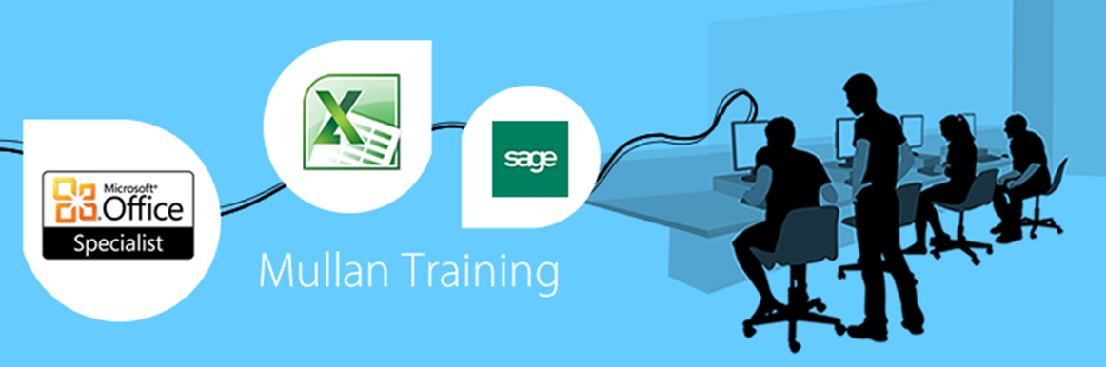

Excel VBA  Introduction |  | 

PREREQUISITES
- A high proficiency of Microsoft Excel is essential, or completion of our 2 day Advanced MS Excel course.

BENEFITS
- At the end of the course the delegate will have covered the fundamentals of VBA, including:
- working with procedures and functions
- understanding objects
- using expressions, variables and intrinsic functions.

COURSE CONTENT

INTRODUCTION  - What is a Macro  - Recording a Macro  - Relative References  - Running A Macro  - Running A Macro From The Macros Dialog Box  - Editing A Macro With Visual Basic  ASSIGNING MACROS TO BUTTONS AND OBJECTS  - Assigning a Macro to a Button on a Sheet  - Assigning a Macro to a Drawn Object on a Sheet  - Assigning a Macro to a Button on a Toolbar  - Creating A Short-Cut Key To Run A Macro  VISUAL BASIC EDITOR  - Objects  - Methods  - Properties  - Programming Tools  - The Menu Bar  EDITING MACROS  - The Visual Basic Editor  - The Project Explorer  - The Code Window  - Procedures  - Inserting Comments  - Printing a Visual Basic Module  THE RANGE OBJECT  - The Cells Property  - The Range Property  - Flexible Ranges  - Range Contents | WORKBOOKS AND SHEETS  - Activating a Workbook  - Activating a Worksheet  - ThisWorkBook  - Running Code  - Run Mode And Design Mode  - Running Code From The Development Environment  THE PROJECT EXPLORER  - Using The Project Explorer  THE PROPERTIES WINDOW  - Changing A Property  USING CONSTANTS  - Excel Constants  - Variable Constants  OBJECTS PROPERTIES AND METHODS  - Controlling Objects with their Properties  - Performing Actions with Methods  - Performing Multiple Actions on an Object  EXCEL OBJECTS  - Objects, Properties And Methods  - Getting & Setting Properties  VARIABLES  - Using Variables In Routines  USING BASIC FUNCTIONS  - Inputbox Function  - Msgbox Function  - Using A Set Statement

COURSE CONTENT

BUILDING FORMULAE CONTROL STRUCTURES  - If…Then Decision Structures  - Logical Operators  - For… Loops  - Do Loops  EVENT HANDLING  - Vba Editing & Debugging  - Auto Macros  - Error Handling  CONTROLS, DIALOGUE  - Built-In Dialogue Boxes  - Predefined Dialogue Boxes  - Custom Forms  - Worksheet Forms  - User-Defined Forms  - Adding Form Controls  - Form Control Properties  - Control and Dialogue Box Events  - Displaying and Dismissing a User Form  - Handling Form Controls  CONTROL STRUCTURES  - Conditional Control Structures  - Looping Control Structures  - Non-Structured Statements  - Subprocedures | 